COMPUTER ORGANIZATION AND ASSEMBLY LANGUAGE

TOPIC:
DEALING WITH REGISTERS

NAME:
MUHAMMAD TALHA
ROLL NUMBER:
241890
SECTION:
4/A

INSTRUCTOR:
MS ROMANA MAROOF

REGISTER TYPE | REGISTERS | SIZE | SIMPLE USE
General purpose | Ax, bx, cx, dx | 16-bit | Used for data and calculations
Segment | Cs, ds, ss, es | 16-bit | Store memory segment addresses
Index | Si, di | 16-bit | Used for array and string operations
Pointer | Sp, bp | 16-bit | Point to stack data
Instruction | Ip | 16-bit | Holds address of next instruction
Flag | Flags | 16-bit | Stores result status (zero, carry, etc.)
LABTASK #2.1
Create the source for of given code in Screen shot debug the program and identify the
register values and registers.
STEP #1
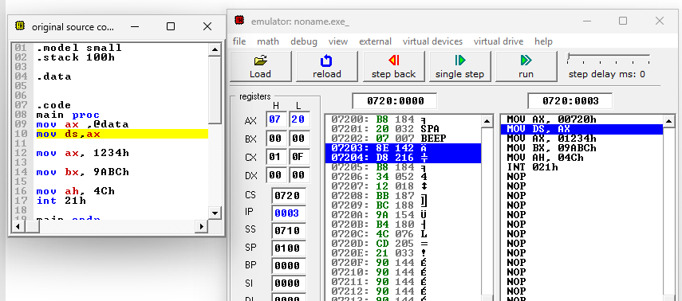DESCRIPTION:
In the first step, the ax register gets the segment address i.e. data address
STEP #2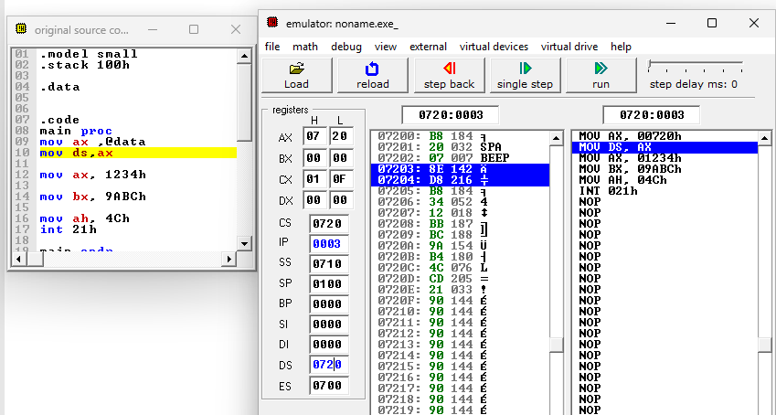
DESCRIPTION:
In this step the ds register gets the values from ax register
STEP #3
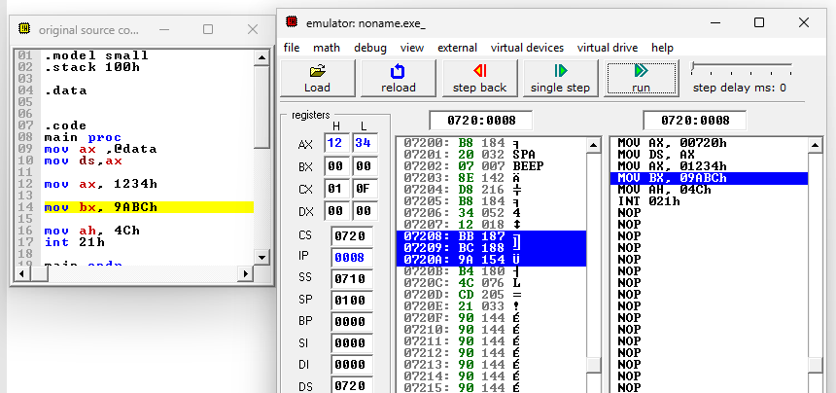
DESCRIPTION:
In this step a new value is stored in the ax register.
STEP #4
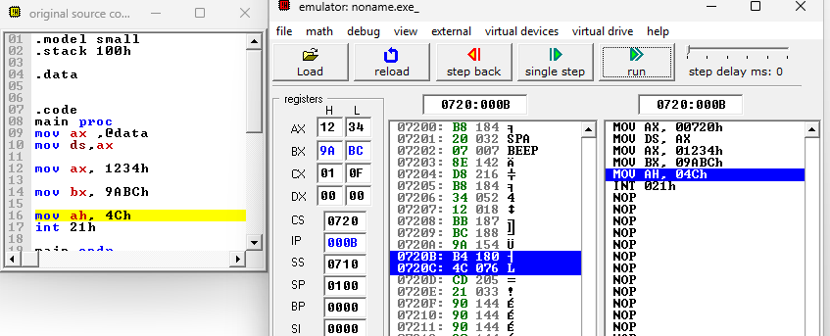
DESCRIPTION:
In this step, the bx register gets a value i.e. 9abc

STEP#5
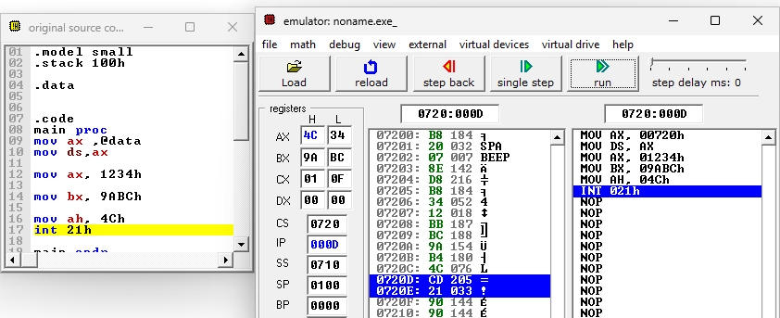DESCRIPTION:
In this structure only the part ah of ax register is updated
FINAL:
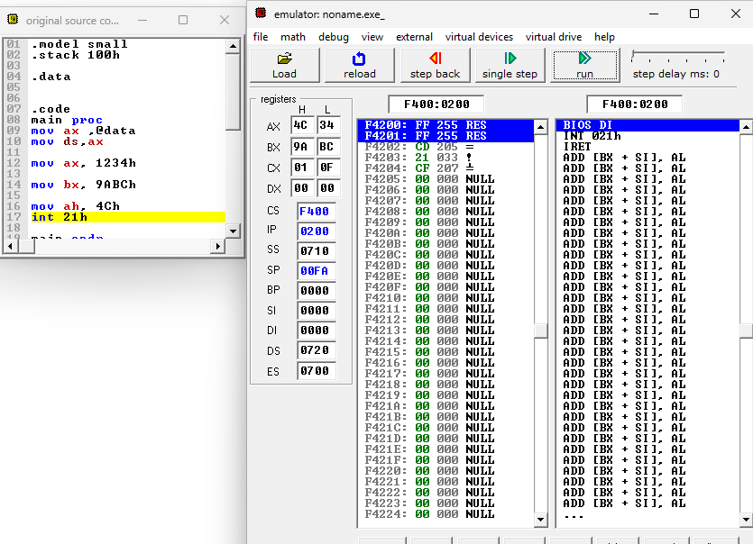
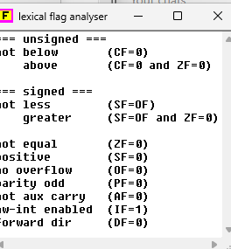
FLAGS:
Here only flag if is changes which tell that’s IF = 1 → interrupts allowed

===================================================================

LAB TASK 2.2
Demonstrating 8-bit Registers (Data Transfer Only)
Results:
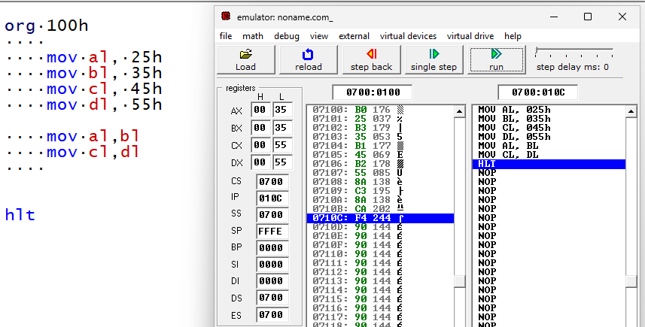
Description:
- We store value of 25 h in AL register
- We store value of 35 h in BL register
- We store value of 45 h in CL register
- We store value of 55 h in DL register
- Here we exchange values of AL and BL registers
- Here we exchange values of CL and DL registers

LAB TASK 2.3
Demonstrating 16-bit Registers (Data Transfer Only)
Results:
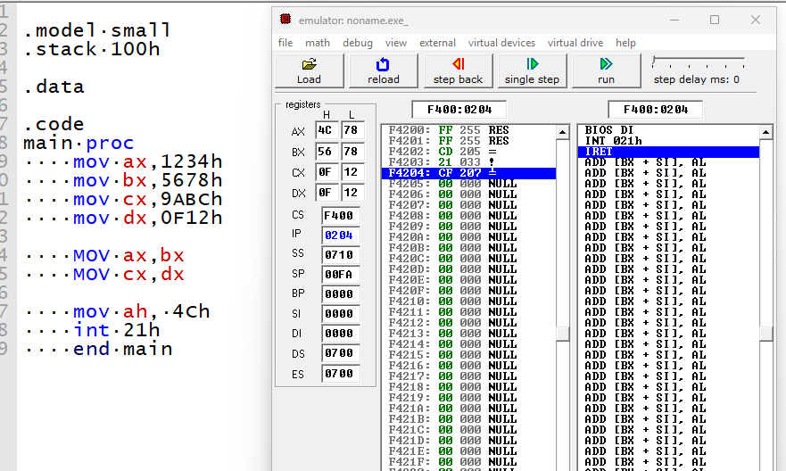
DEESCRIPTION:
- Ax gets value 1234h
- Bx gets value 5678h
- Cx gets value 9abch
- Dx gets value 0f12h
- Value of bx (5678h) is copied into ax
- Value of dx (0f12h) is copied into cx
- Ah is set to 4ch (terminate program)
- Int 21h ends the program and returns control to dos

DEBUG RESULTS:
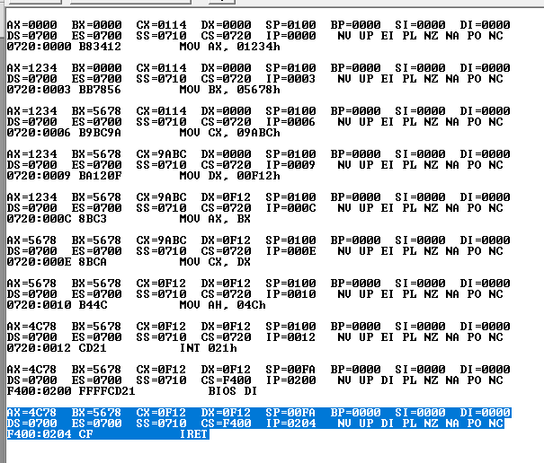
LAB TASK 2.4
Write a set of instructions in x86-64 assembly language that swaps the contents of upper
and lower bytes in BX register.
RESULTS:
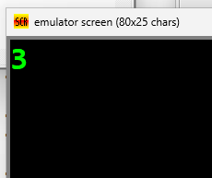
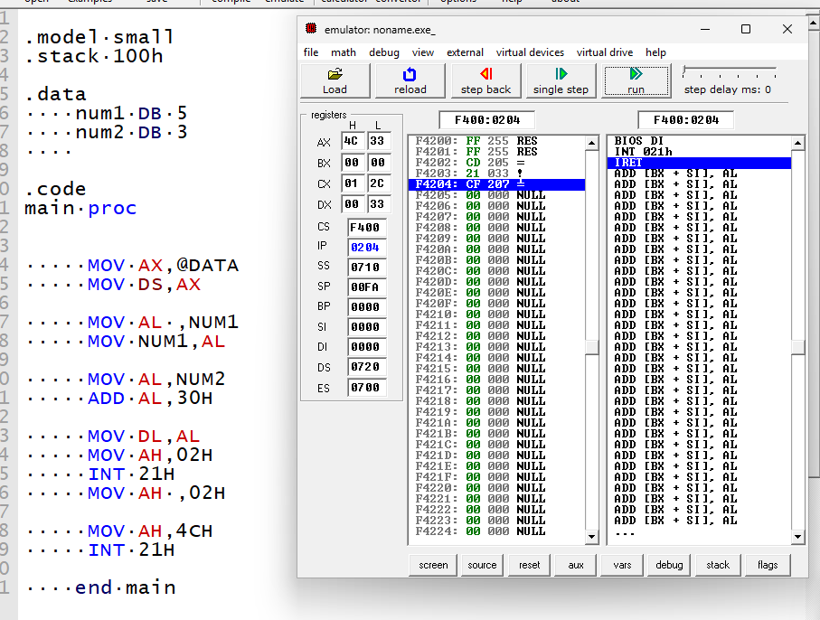
DESCRIPTION:
- Data segment address is loaded into ax
- Data segment register ds is initialized
- Value 5 from num1 is loaded into al
- Value in al is stored back into num1 (no change)
- Value 3 from num2 is loaded into al
- 30h is added to convert number to ascii
- Ascii value is moved to dl
- Ah = 02h prepares dos to print a character
- Int 21h prints the character '3'

